|  |  |
| --- | --- |
| 19DP025 | Planning Proposal - Business Zones - 2A Main Road Boolaroo |
| Council Ref: | RZ/10/2018 - D09122338 |
| Report By: | Senior Strategic Planner - Andrew Donald |

Précis:

Council staff have prepared a Planning Proposal to rezone approximately 20 hectares of land within the former Pasminco Cockle Creek Smelter and Incitec (Pasminco) site at Boolaroo. The land is proposed to be rezoned to allow specialised retail premises and other commercial uses requiring a large floor area. The proposal also seeks to protect the amenity of the adjacent proposed residential subdivision by including an area zoned for mixed use development to provide a transition area between the land uses.

This report seeks Council’s resolution to request a Gateway Determination from the Department of Planning Industry and Environment in respect of the Planning Proposal.

*Do not delete this line*

|  |
| --- |
| **Recommendation:**  Council:   1. Requests a Gateway Determination from the Department of Planning Industry and Environment, pursuant to the *Environmental Planning and Assessment Act 1979,* in relation to the Planning Proposal in Attachment 1; 2. Undertakes consultation with State Government agencies and service authorities and undertakes studies in accordance with the Gateway Determination; 3. Places the Planning Proposal on exhibition, subject to the outcome of the Gateway Determination; 4. Notifies stakeholders and affected landowners of the Gateway Determination and public exhibition period, as required; 5. Makes the Plan, provided Gateway approval is obtained and no objections are received during the public exhibition period. |

*Do not delete this line*

Background:

The subject land forms part of the former Pasminco site. The smelter ceased operations in 2003 and has since undergone major remediation works in accordance with approvals issued by the State Government. Pasminco’s Boolaroo land holdings were rezoned in two stages, with the associated amendments to *Lake Macquarie Local Environmental Plan (LEP) 2004* being finalised in 2010 and 2011 respectively. The zones applied by those LEP amendments were based on a master plan originally submitted by the proponent in 2008. The mix of residential, industrial and commercial zoning that was adopted for the site was largely based on the assumed demand for different land types at the time.

The current land use zoning breakdown is indicated in the table below:

|  |  |  |
| --- | --- | --- |
| *Current Land Use Zone under LMLEP 2014* | *Area*  *(Hectares)* | *% of total former Pasminco/Incitec landholdings* |
| R2 Low Density Residential | 71 | 33.5 |
| R3 Medium Density Residential | 23 | 11 |
| IN2 Light Industrial | 28 | 13 |
| B4 Mixed Use | 11 | 5 |
| SP1 Special Activities (Containment Cell) | 24 | 11.5 |
| E2 Environmental Conservation | 55 | 26 |
| **Total** | **212** | **100** |

Of the land currently zoned for employment-supporting development on the Pasminco site:

* Eighteen hectares zoned IN2 Light Industrial have been developed as a 23-lot industrial subdivision. (The remaining 10 hectares zoned IN2 has limited development potential due to multiple constraints – including a road corridor, various easements and a drainage reserve.)
* Eleven hectares is zoned B4 Mixed Use, approximately half of which is developed (Bunnings Warehouse and a restored heritage-listed building).

Parts of the remaining undeveloped residential zoned land are subject to several active subdivision applications, including an application to subdivide approximately 80 hectares providing for around 750 dwellings.

More recently, the potential for the subject land to support certain commercial activities requiring a large floor area and site area has become apparent. Increasing the ratio of commercial to residential zoned land on the site is consistent with Council’s original intention to facilitate employment-generating land uses on a site that historically supported a significant number of jobs.

Proposal:

The Planning Proposal seeks to amend the *Lake Macquarie Local Environmental* *Plan* (*LMLEP*) *2014* to rezone the subject land (approximately 20 hectares) to enable specialised retail premises and other commercial uses that require a large floor area. The proposal also seeks to establish a suitable interface between the proposed business zones and the adjacent residential zone.

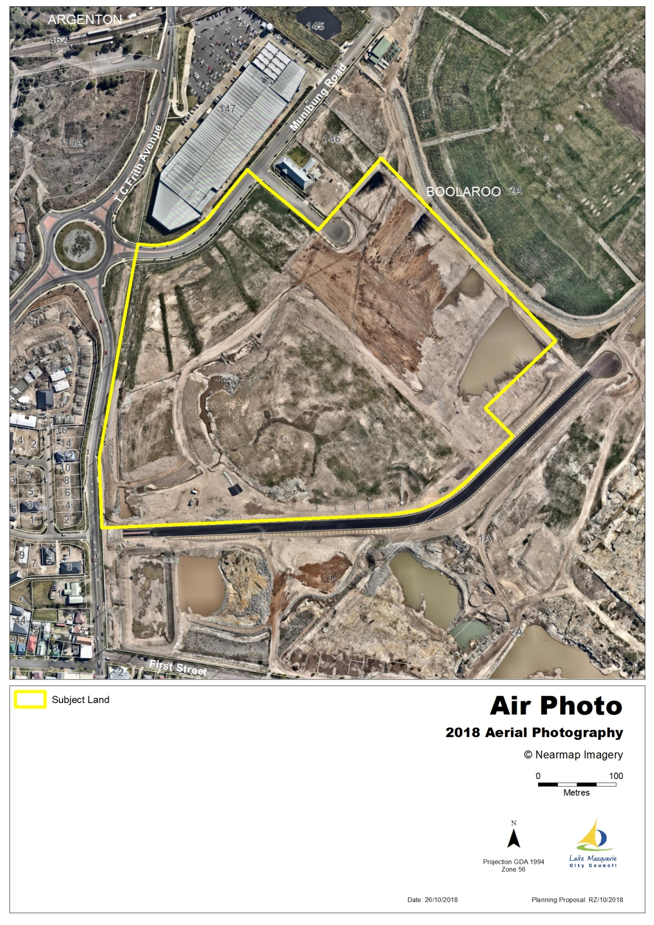

*Land subject to this Planning Proposal*

The land is proposed to be rezoned from R2 Low Density Residential, R3 Medium Density Residential and B4 Mixed Use to B7 Business Park and B4 Mixed Use. The proposal also includes corresponding changes to the Lot Size Map and Height of Building Map within *LMLEP 2014*. These changes are explained in the Planning Proposal included as Attachment 1.

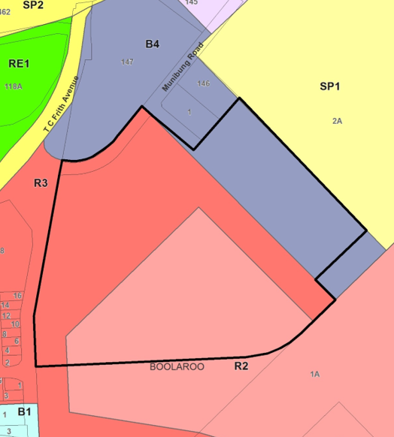

*Existing Zones*

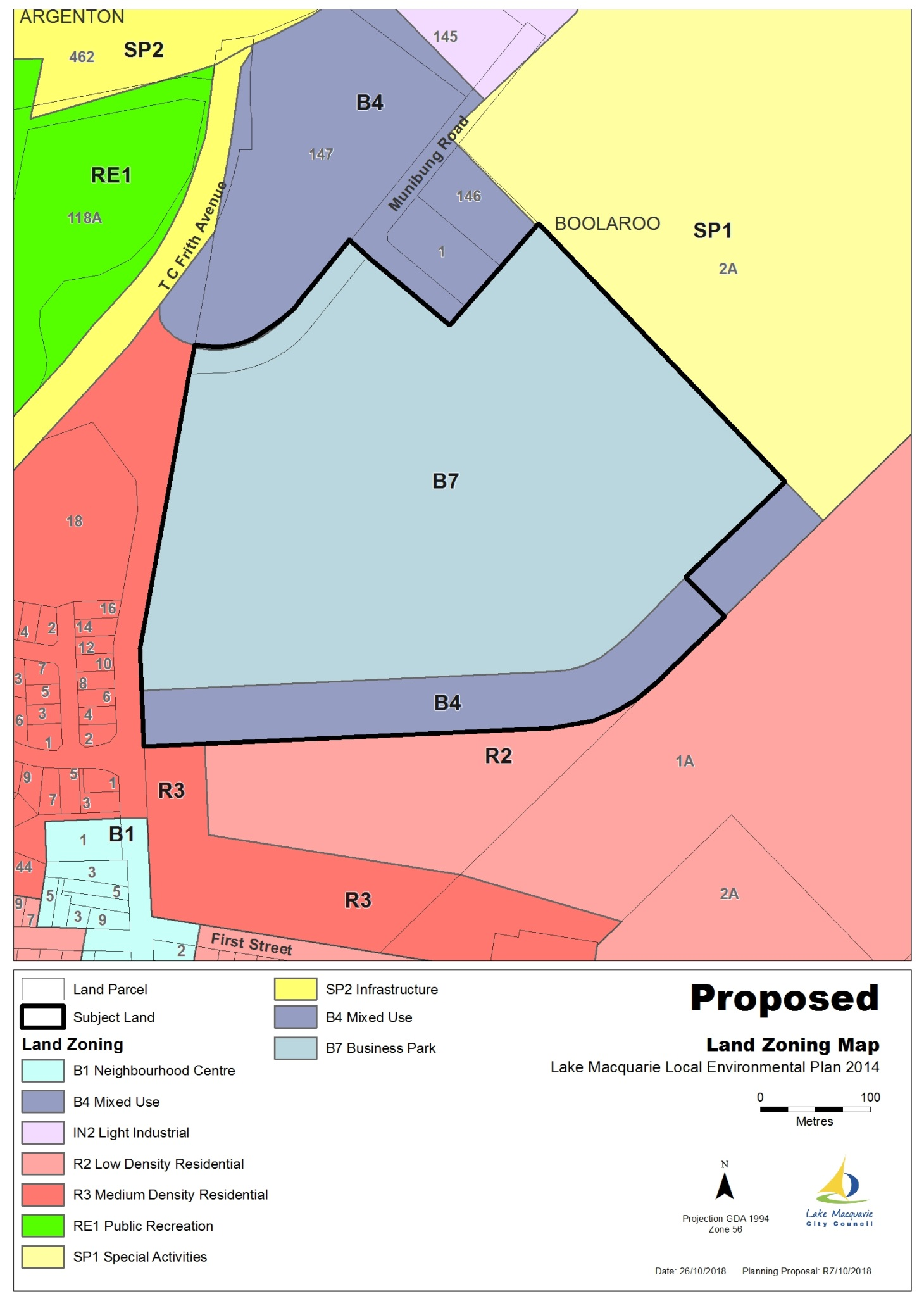

*Proposed zones*

The rationale for the proposed zoning, in particular the strip of B4 zoning to align with the recently-constructed Fotheringham Road, is to ensure permissibility of the uses envisaged for the site while protecting the existing retail hierarchy in the surrounding area, as well as the amenity of the future residential subdivision immediately south of the subject land. This is further explained by comparing uses permitted with consent in the B4 and B7 zones respectively:

*Uses permitted in Zone B4 but not B7 include:*

Multi-dwelling housing, residential flat buildings, seniors housing, shop-top housing, hotel or motel accommodation, serviced apartments, pubs, restaurants or cafes, shops, registered clubs.

*Uses permitted in Zone B7 but not B4 include:*

High-technology industries, light industries, self-storage units, wholesale supplies, warehouse or distribution centres

*Permitted uses common to Zone B4 and Zone B7 include:*

Business premises, office premises, specialised retail premises, take-away food and drink premises, plant nurseries, entertainment facilities, service stations, educational establishments, health services facilities, public administration buildings.

Excluding the containment cell and land zoned E2 Environmental Conservation (generally steep undevelopable land in the higher parts of the site), the existing and proposed zone breakdown for the entire former Pasminco site appears in the charts below.



|  |  |
| --- | --- |
| *Current Land use zone* | *Proposed Land use zone* |

It is proposed that Council forward the Planning Proposal, at Attachment 1, to the Department of Planning Industry and Environment and request a Gateway Determination.

Consultation:

This Planning Proposal has been prepared in consultation with Council’s Rezoning Advisory Panel, which comprises staff from Integrated Planning, Development Assessment and Certification, Community Partnerships, Property and Business Development, Environmental Systems and Asset Management departments. Feedback from the Rezoning Advisory Panel has been considered in preparing the Planning Proposal.

Implications:

Policy Implications:

Planning Policy implications are detailed in the Planning Proposal at Attachment 1.

The site is within the North West Lake Macquarie Catalyst Area which features in both the Imagine Lake Mac Strategy and the Greater Newcastle Metropolitan Plan 2036 (GNMP).

The GNMP recognises that “a positive legacy of Greater Newcastle’s industrial and heavy manufacturing past is land and infrastructure in large land holdings in central locations”. The former Pasminco site at Boolaroo is one such example.

The Planning Proposal is consistent with Action 7.1 in the GNMP which calls on councils to:

* *Build capacity for new economy jobs in areas well serviced by public transport and close to established centres by:*
* *Enabling a greater range of employment generating uses in appropriate industrial and business areas, and*
* *Ensure an adequate supply of employment land, including industrial zoned land, to cater for demand of urban services in accessible locations.*

The proposal also aligns with the outcomes envisaged for the “Munibung Precinct” within the North West Lake Macquarie Catalyst Area, articulated in the GNMP as follows:

*Lake Macquarie City Council will*:

* *Align local plans to facilitate urban renewal through increased housing density and mixed-use including large format retail and office uses, and*
* *Explore options to improve pedestrian connections to Cockle Creek Train Station with Transport for NSW.*

Environmental Implications:

The subject land of this Planning Proposal is devoid of vegetation, having undergone major remediation and earthworks following cessation of the former heavy industrial use of the site. Site audit statements have been issued for the land confirming that remediation has been completed in accordance with the site’s remedial action plan.

Social Implications:

The proposed rezoning will result in a net increase of 15 hectares of employment land in a strategic location within the North West Lake Macquarie Catalyst Area. The business park will complement the existing Bunnings Warehouse immediately north of the subject land, and will support the nearby Cardiff-Glendale strategic centre. The strip of land proposed to be zoned for mixed use provides for a variety of commercial and some residential uses that will further enhance the economic potential of the locality.

Lake Macquarie City currently has a total of 138 hectares of land zoned B7 Business Park. An analysis of existing B7 Business Park zoned land within the Local Government Area (below) shows that this land is either fully developed, has DA approval, or is greater than 25km from the subject site.

|  |  |  |  |
| --- | --- | --- | --- |
| *B7 zoned land - Location* | *Area (ha)* | *Development status* | *Distance from subject land (km)* |
| Pennant Street, Cardiff | 13 | Developed | 3 |
| Macquarie/Hillsborough Road, Warners Bay | 35 | Developed | 7 |
| Medcalf St, Warners Bay | 9 | Developed | 6 |
| Groves Road, Bennetts Green | 9 | Developed | 12 |
| Pacific Highway, Bennetts Green | 13 | DA approved | 12 |
| Pacific Highway, Belmont North | 10 | Developed | 14 |
| Gateway Boulevard, Morisset | 12 | Developed | 30 |
| Gimberts Road, Morisset | 37 | Undeveloped | 30 |

Further investigation of economic impacts would be undertaken following receipt of a Gateway Determination.

Infrastructure Asset Implications:

There are no direct infrastructure asset implications associated with the Planning Proposal.

Fotheringham Road, forming the southern boundary to the subject land, has been designed as a residential collector road. Accordingly, planning to occur following or in conjunction with Planning Proposal, should reflect the need for heavy vehicle access to the subject land to be via Munibung and Hague Roads.

Financial Implications:

There are no direct financial implications from the Planning Proposal, apart from staff time and supporting studies that may be required to justify the LEP amendment. At a minimum, such studies are expected to include a traffic impact assessment. Quotes have yet to be sought, however the total cost for externally prepared studies are not expected to exceed $50,000. Adequate funds are available in Integrated Planning’s 2019/2020 budget to cover the cost of these studies; however, Council has entered into discussions with Hunter and Central Coast Development Corporation (HCCDC), who are soon to gain ownership of the subject land, regarding the possibility of HCCDC refunding Council for costs incurred in the rezoning process.

Risk and Insurance Implications:

The proposal to rezone the subject land from R2 Low Density Residential, R3 Medium Density Residential and B4 Mixed Use to B7 Business Park and B4 Mixed Use does not present any specific risk implication to Council.

The risks associated with preparing a Planning Proposal are minimised by following the process outlined in the *EP&A Act 1979*, the *Environmental Planning & Assessment Regulation 2000*, the Department of Planning Industry and Environment guidelines, and Council’s LEP Amendment Procedure.

Options:

1. Council resolves to support the Planning Proposal to amend *LMLEP 2014* to rezone the subject land from R2 Low Density Residential, R3 Medium Density Residential and B4 Mixed Use to B7 Business Park and B4 Mixed Use. This is the preferred option and will create opportunities for large format retail and other employment-generating uses on the Pasminco site. This is consistent with the Imagine Lake Mac Strategy and Greater Newcastle Metropolitan Plan 2036.
2. Council resolves not to support the Planning Proposal to amend the *LMLEP 2014*. This is not the preferred option as the proposal has strategic merit and will facilitate a more appropriate balance between business and residential uses on a strategic site.

Conclusion:

The Planning Proposal to rezone approximately 20 hectares of land within the former Pasminco site at Boolaroo from predominantly residential zones to predominantly business zones will facilitate much-needed economic development within the North West Lake Macquarie Catalyst Area. It is recommended that Council seek a Gateway Determination from the Department of Planning Industry and Environment to enable the proposed rezoning to progress to more detailed investigation and consultation.

*Do not delete this line*

Manager Integrated Planning - Wes Hain

Attachments:

|  |  |  |  |
| --- | --- | --- | --- |
| 1. | Planning Proposal - Business Zones - 2A Main Road Boolaroo - Pre-Gateway version |  | D09117671 |